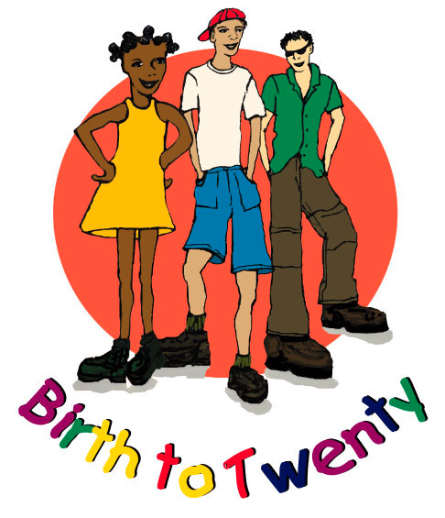

University of the Witwatersrand

Department of Paediatrics and Child Health

BIRTH TO TWENTY BARA SITE: 17TH YEAR
ADOLESCENT FRACTURE QUESTIONNAIRE

BTT ID NUMBER :

Yes
No
Did you break / fracture a bone in your body in the past 24 months (2 years)?

If Yes, please tell me about this event/s.

Incident  Number | Which side of  your body  (Right / Left) | Which bone did you break / fracture?  Please MARK the sites of fractures on the skeleton provided at the back of the page and number the fractures in order of occurrence with the year or age of occurrence next to the fracture. | When did this happen?  (Year / Age) | How did this happen? Please choose from the options provided in the table below and enter for e.g. 2.2 and if not listed in the table then describe what happened
1.

2.

3.

4.

5.

GRADE 1 (Slight trauma)
1.1 Falling to the ground from standing on the same level (e.g while walking you slipped and fell and had a fracture)
1.2 Falling from less than 0.5m (falling from stools, chairs and beds)
GRADE 2 (Moderate trauma)
2.1 Falling from between 0.5 – 3 m (e.g. a wall or jungle gym or tree)
2.2 Falling down stairs, from a bicycle, roller blades, skateboard or swing
2.3 Playground scuffles (e.g. wrestling or boxing)
2.4 Sport injuries (e.g. soccer, rugby, netball, hockey etc)
2.5 Slamming fingers into a door or knocking against a solid object
GRADE 3 (Severe trauma)
3.1 Falling from a height > 3 m (falls from windows or roofs)
3.2 Motor vehicle or pedestrian accidents
3.3 Injuries caused by heavy moving or falling objects (e.g. bricks or stones)
4. Do not recall or cannot remember

Quality checked by: Date:

